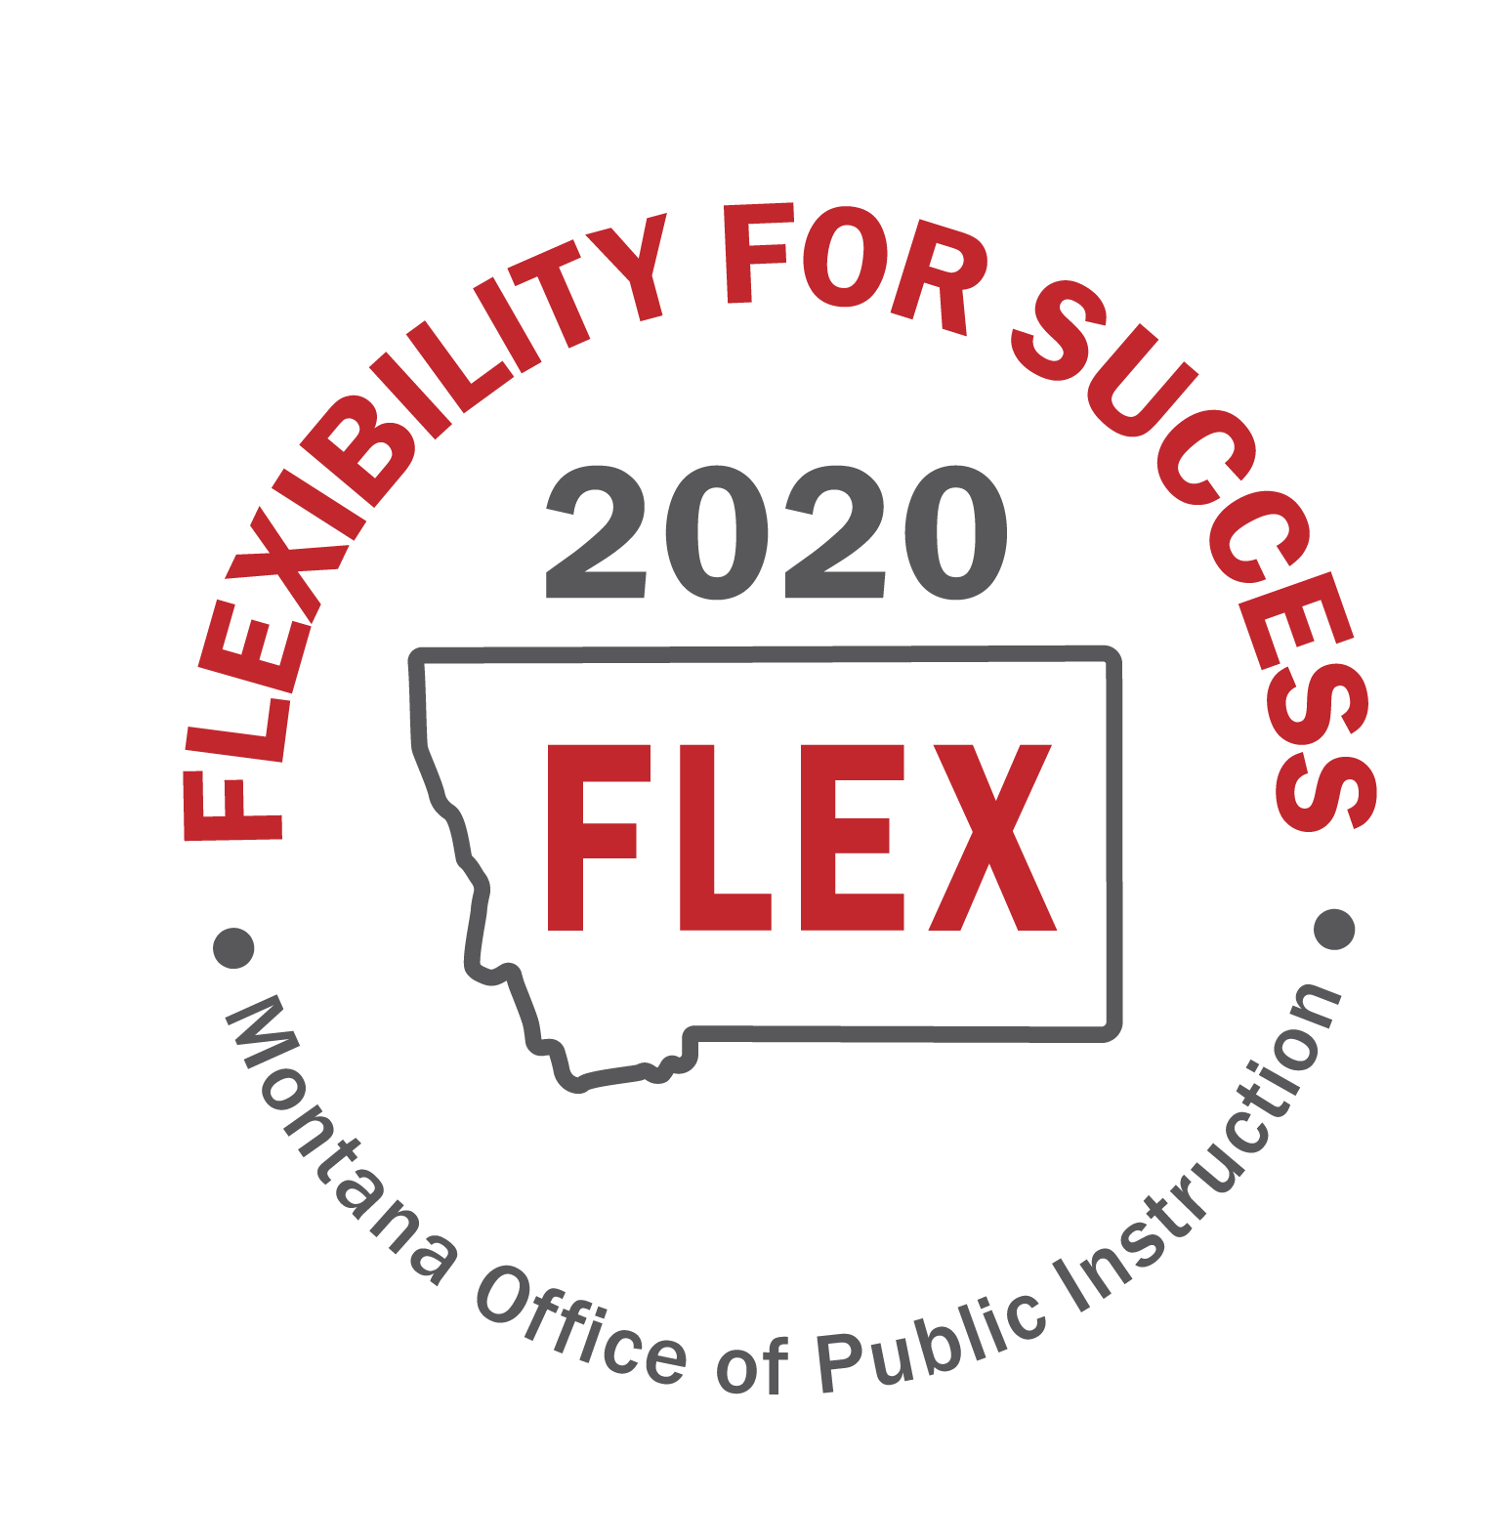

“MT FLEX2020” Task Force
Session 2
June 3rd, 2020
Focus Group Note Catcher

Focus Group: E- Leveraging federal flexibilities and resources
Note Taker: Tracy Moseman
Group Members: Godfrey Saunders, Belgrade Public Schools Superintendent
Tobin Novasio, Lockwood Public Schools Superintendent
Monte Silk, Sidney Public Schools Superintendent
Tom Korst, Hamilton Public Schools Superintendent
Dianne Burke, MQEC Executive Director
Allison Evertz, Joliet Public Schools Superintendent
Jon Martin, Noxon Schools Superintendent

Questions | Time Allotment | Notes
- After pondering the Essential Questions, what key ideas come to mind?  - Write key ideas that come to mind  - Do not judge or discuss the ideas  - Come up with as many ideas as possible | 5 minutes  30 second rounds/task force member | Title Funding:  - Given the achievement gaps we think we might experience because of COVID, it would be good to have flexibility with Title funds and how they are used instead of having them targeted towards specific groups.  - Second, flexibility on qualifications to become a title school. We will have schools that won’t qualify, but will have the same needs because of the learning issues schools are going to face? Huge concern.  - We are a targeted school and we are concerned about being able to serve the students that have not been engaged and not doing well. We would also like to see flexibility with title funding to serve those students.  Blended Learning burden on educators:  - Worried about overburden of teachers doing in person and on-line teaching. Are there partnership opportunities with Mt. Digital Academy so teachers don’t have to do both because that will be impossible. This could be a union issue having teachers do on-line learning in the evening after teaching in the classroom during the day.  School Nutrition Programs  - Flexibility with school nutrition programs of qualifying for free/reduced meals including looking at Medicaid/Chip other ways to qualify requirements so we don’t have food insecurities.  Attendance:  - Eliminate attendance in ESSA or change the definition of attendance.  Technology:  - Is there flexibility in E-Rate? We are looking at hotspots for students that don’t have access. Best price right now is $50 per month per household. Current education system is segregated by income level and this is making it worse.  Group is worried about losing a generation of kids through the homework gap.
2) Based on the shared ideas,  consider the following:  - What opportunities would address the key ideas?  - What other opportunities can you think of?  - In the future, what would you like to do differently? | 15 minutes | - Title flexibility was one of biggest themes for all size districts.  - Could OPI work with MTDA to set up a fee schedule where a district could pay to have a child enrolled if they only have a handful at each grade level needing on-line learning?  - Develop a curriculum that can be taught face to face and on-line.  - May destinate an educator at each level as the virtual teacher to avoid teachers doing both online and in person.  - Ed Flex Program, should Montana apply? The group didn’t think this was necessarily a great plan for Montana.  - A day/B day schedules will drive need for attendance waiver in ESSA plan.  - School Wide Title schools feel flexible with the spending. Targeted would like to see more flexibilities so they can serve students they know have huge gaps. They currently have to send letters and get parent approval to serve those students, but parents sometimes refuse the services for fear of stigma. It would be nice for targeted to serve students as a school wide model for at least two years without needing parent approval.  - We would like to run afterschool/summer tutoring and use some of the money for transportation of students to the program. We would also like to use the funds for summer school.  - Some schools are wanting to save the money to run summer school next summer when things may be more “normal”.  - Following the next legislative session, we are nervous about our 2021-2022 state budgets will look like and we are worried about school budgets down the road. We would like to have more flexibility of carrying over our title money and save for a rainy day. This may be a reason for the Ed Flex program.  - On-line/blended is going to be difficult without 500-600 new Chromebooks.
Whole Group Share-Out | 10 minutes | Share out group responses for # 1 and #2
3) Evaluate the Ideas  - What flexibilities are needed to address the key ideas and opportunities?  - Evaluate the flexibilities based on the following criteria: Specific; Balanced; Realistic; Lasting; Fair | 15 minutes | - Can we get title funds school wide for everyone so we can capture those students who don’t apply or parents don’t want to fill out permission. Diane and Allison want to look at title regulations between now and next week and see what flexibilities are available.  - Modify ESSA plan for attendance qualifier. What is the process to amend the plan? Do we need to find another criteria to replace attendance? Diane will look into this as well. Or, could we change the definition of attendance to meet the needs of remote learning?  - Several groups talked about availability of devices and internet access. We should look at federal telecommunications programs and funding where we might get some funding/assistance. Some are already using E-Rate so could we partner/ask for funds through them?  - We have a data payment that we have at the state level $20/student but we know technology costs are much more than that.  - Civil Rights Data Collection: Could we waive this next year? We won’t have any of the data for the last part of the year and possibly into the fall of next year. It is cumbersome and not user friendly.  - Can we use funds OPI set aside for statewide assessment and repurpose?

